
Survey Site
Final Project
Version #4.0

All work Copyright © 2014 by Evan Pugh & Jordan Cooper.
All rights reserved.

Evan Pugh
Jordan Cooper

April-14-14

Table of Contents
Description Page 3.
Wireframes Page 3.
Screen Shots Page 7.
Future Plans Page 9.

Site Description

This site was created to allow users to develop their own surveys and post them to the general public. Anyone can become a user of the site by registering online, through the register page, where we will require their unique user name, password, and email address. Once the user is registered he or she can log in to the site and begin to access its survey development pages. This page offer the user the choice between a short-answer and agree/disagree and allows them to title their survey, and develop a five question survey and release it to the public for a pre-determined amount of time(determined by the owner of the survey). The site’s main page is open to the public, visitors are able to see a list of available surveys and by selecting one they are brought to the survey and prompted for answers. After the survey has been completed the user is thanked, and redirected to the home site. After a survey has been completed the owner of the survey can view statistics on his or her survey through our statistics page.

Wireframes

Home Page

Navigation Bar

Logo & title

Content

Survey Tables

Footer

Create a Survey

Navigation Bar
Create a Survey

Survey Input Fields

Submit btn

Footer

Take a Survey
Navigation Bar
Take a Survey

Survey Question

Text Field/radio buttons

Footer

Login

Navigation Bar

Log In
Username:
Password:

Footer

Register

Navigation Bar

Log In
Username:
Password:
Password:

Footer

Stats

Navigation Bar

Column Titles
Column Data

Submit

Footer

Screenshots

Home
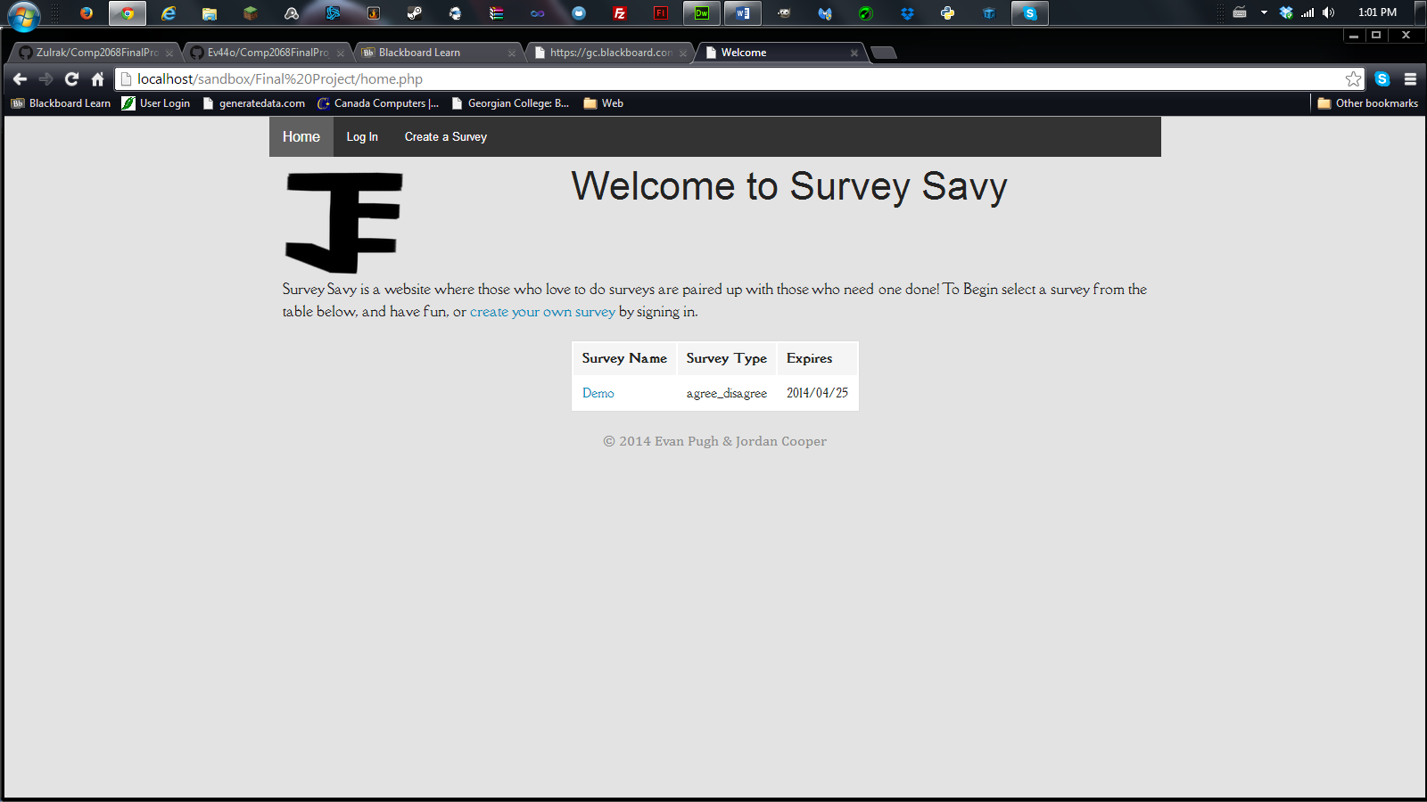
Create a Survey
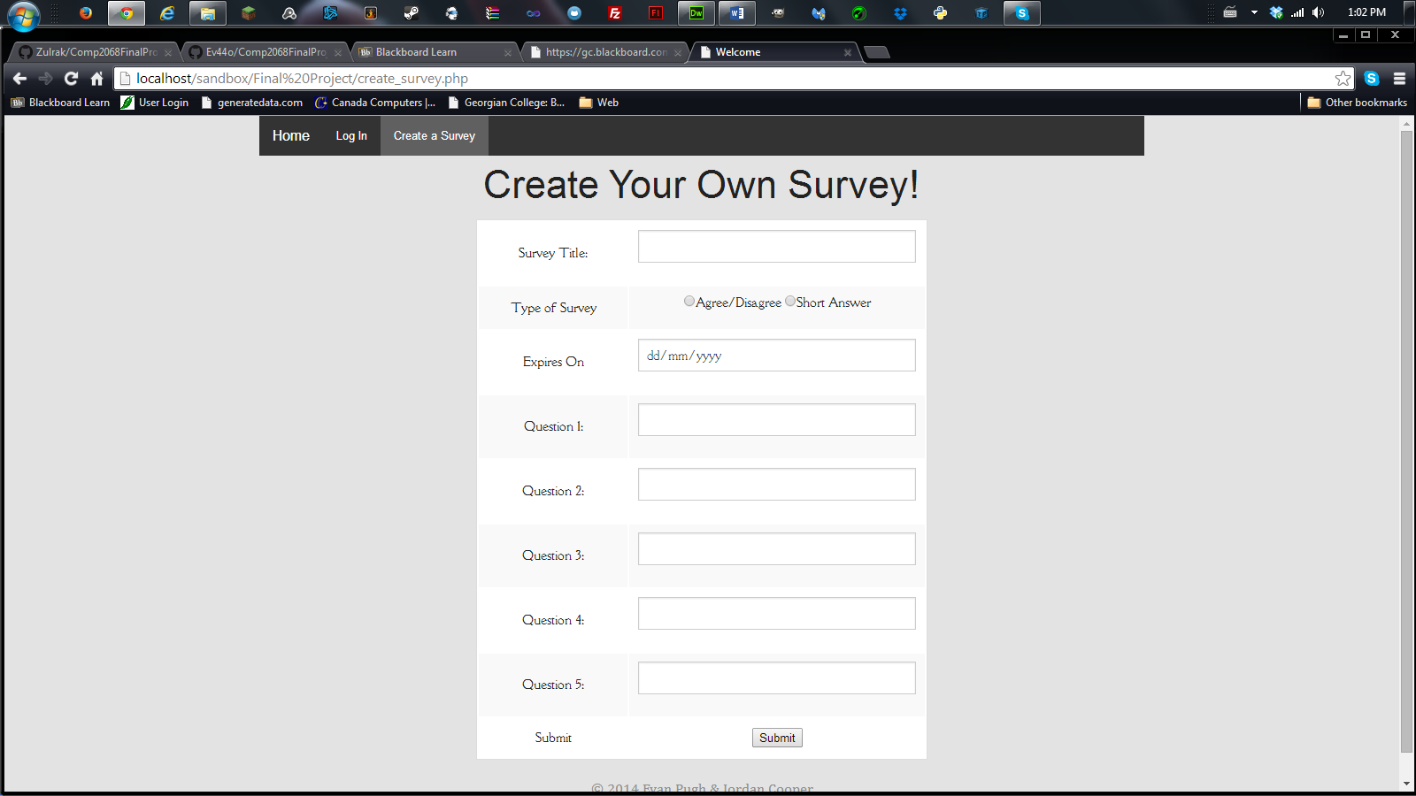
Take a Survey
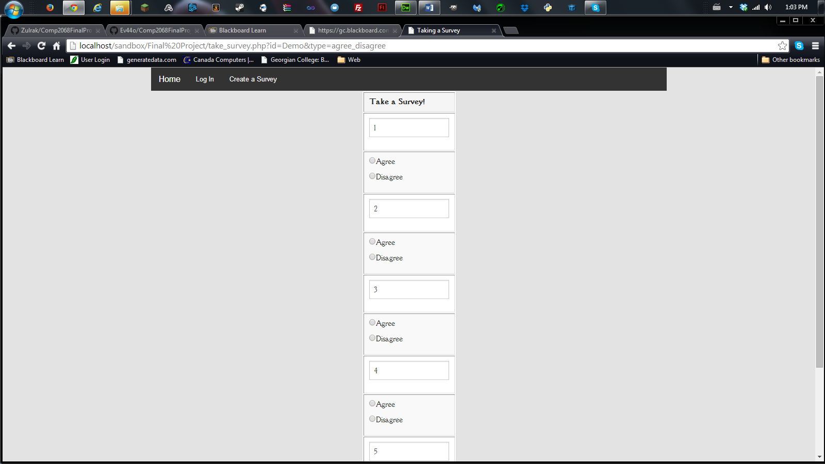
Log in
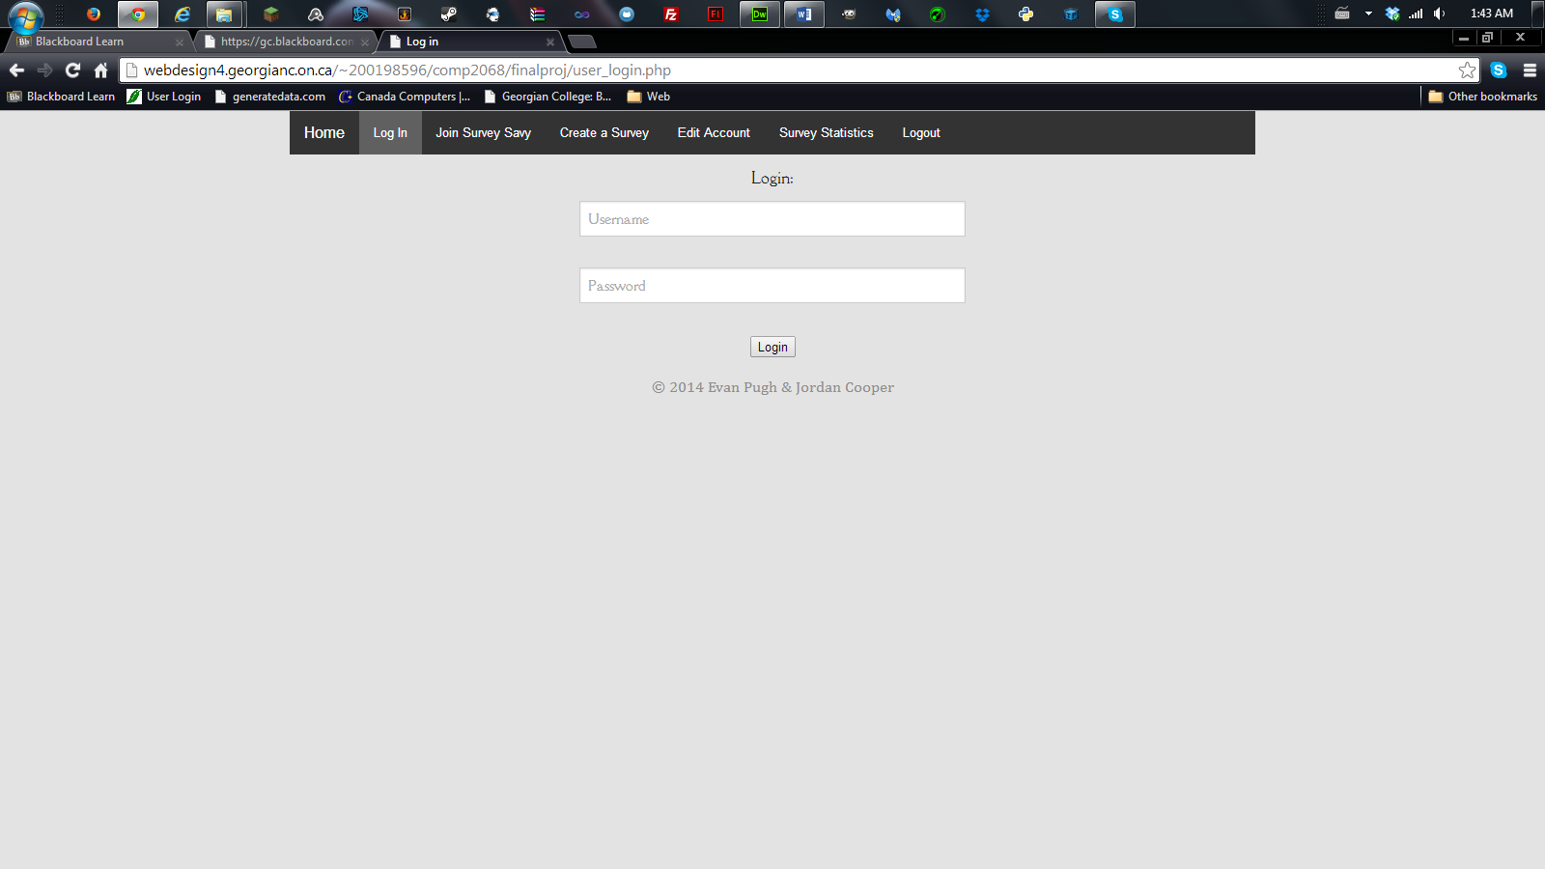
Survey Stats
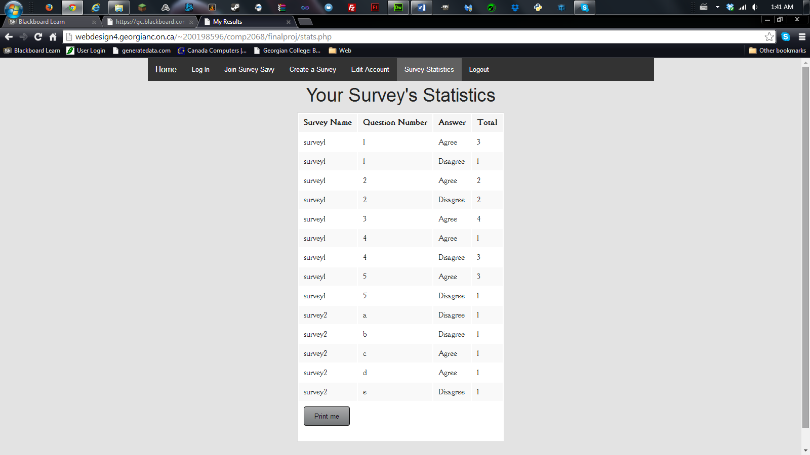
Register
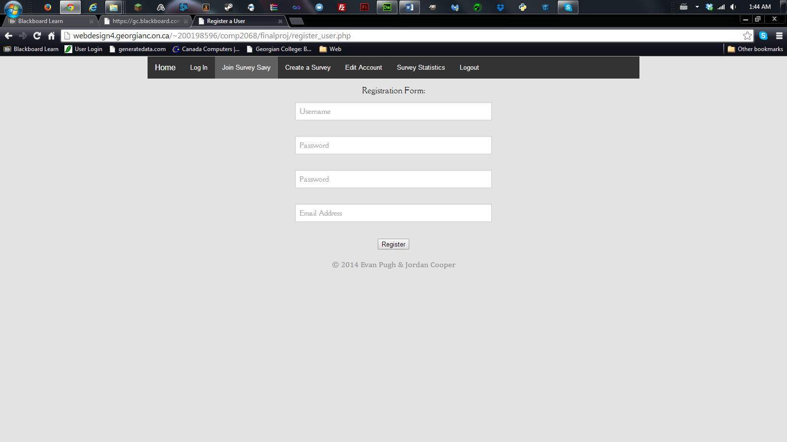

Future Plans

Currently the user can only add 5 questions to a survey. A future implementation can include dynamic creation of additional questions based on how many the user wants to make.
Currently surveys cannot be edited, a future feature would include the ability to edit the survey after it has been saved by the creator, this would include extending the expiry date, and the questions themselves.

